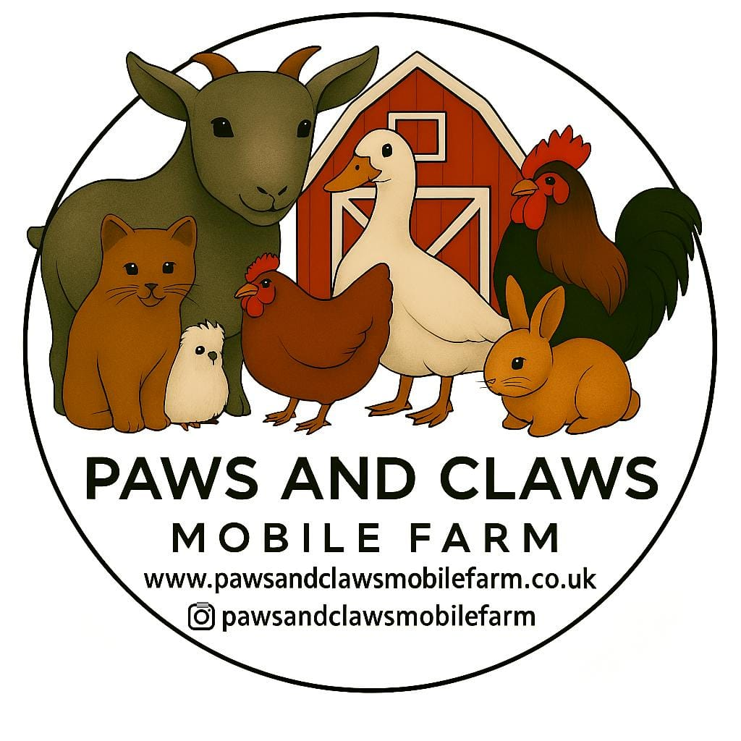
Hygiene & Infection Control Policy

Owner: Rebecca Rathore
Policy Created: February 2026
Review Date: February 2026

Strict hygiene procedures are followed to reduce the risk of infection.

Procedures:
• All participants must wash or sanitise their hands after touching animals.
• Hand sanitiser is provided at all visits.
• Animals are kept away from food preparation or eating areas.
• Surfaces and equipment are cleaned and disinfected after visits.
• Any animals known to carry zoonotic risks such as Salmonella are handled with extra precautions.
• Participants with open wounds should avoid handling animals.

