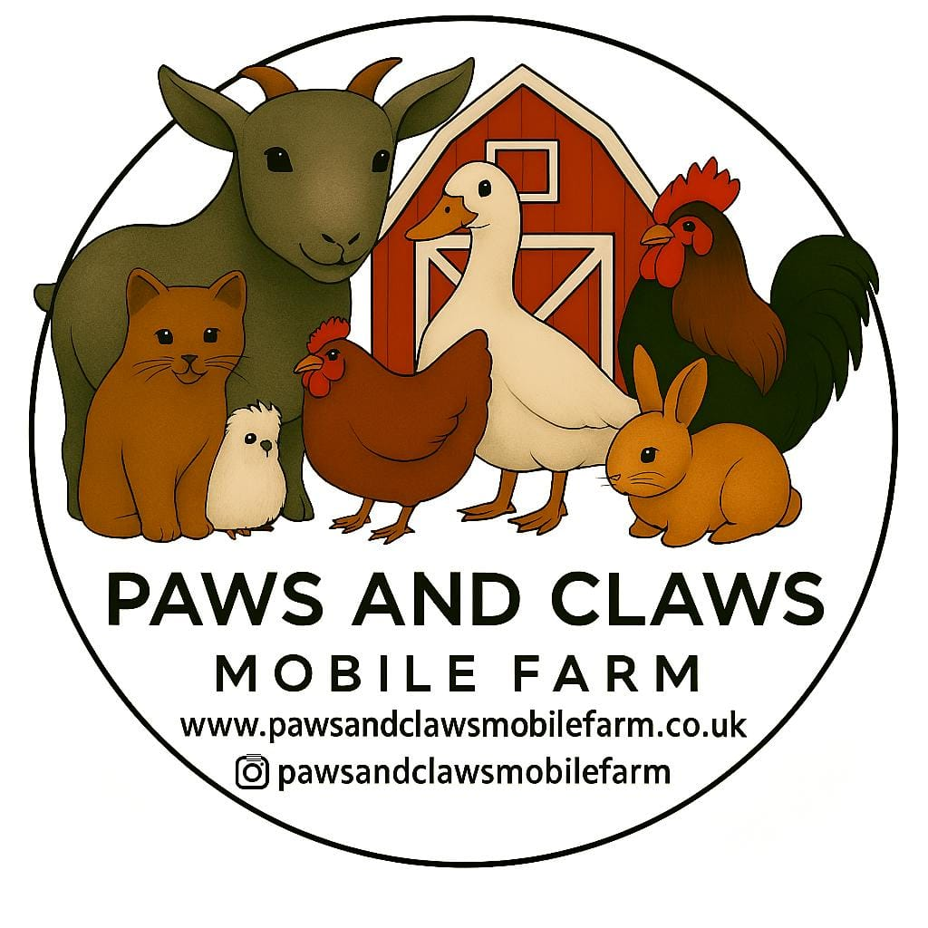
MOBILE FARM RISK ASSESSMENT
Goats, Rabbits, Chickens & Ducks
Business Name: Paws and Claws Mobile Farm
Contact Name: Sean/Becky
Telephone / Email:
Date of Assessment:1.2.2026
Review Date:1.2.2027
Activity: Mobile farm animal visits to schools, nurseries, early years settings and events
Location: Client premises (indoors and outdoors where suitable)

1. Animal Handling – Goats
Hazard | Who might be harmed | Risk | Control Measures | Risk After Controls
Head butting, nibbling, stepping on feet | Children, staff, public | Medium | Goats are well-handled and accustomed to children. No unsupervised handling. Clear instructions given. Children seated when feeding where possible. Staff supervise closely at all times. | Low

2. Animal Handling – Rabbits
Hazard | Who might be harmed | Risk | Control Measures | Risk After Controls
Scratches or distress if handled incorrectly | Children, staff | Low | Rabbits handled by staff or with support. Children taught correct handling. Rabbits kept calm and handled for short periods only. | Low

3. Animal Handling – Chickens & Ducks
Hazard | Who might be harmed | Risk | Control Measures | Risk After Controls
Pecking or wing flapping | Children, staff | Low | Birds are accustomed to handling. Children shown how to stroke gently. Handling closely supervised. | Low

4. Zoonotic Diseases (e.g. E. coli, Salmonella)
Hazard | Who might be harmed | Risk | Control Measures | Risk After Controls
Illness from animal contact | Children, staff, public | Medium | Mandatory hand washing after contact. Hand washing facilities or sanitiser provided. No eating, drinking or hand-to-mouth activity in animal area. Clear signage displayed. | Low

5. Hand Hygiene
Hazard | Who might be harmed | Risk | Control Measures | Risk After Controls
Inadequate hand cleaning | Children, staff | Medium | Hand washing supervised by staff. Anti-bacterial gel used where sinks unavailable. Schools advised in advance of requirements. | Low

6. Allergies and Asthma
Hazard | Who might be harmed | Risk | Control Measures | Risk After Controls
Reaction to animal dander, hay or straw | Children, staff | Low | Schools advised to identify allergies beforehand. Animal areas well ventilated. Hand washing after contact. | Low

7. Slips, Trips and Falls
Hazard | Who might be harmed | Risk | Control Measures | Risk After Controls
Mud, straw, uneven surfaces | Children, staff, public | Medium | Area checked prior to setup. Pens kept clean and tidy. Spills cleared promptly. Appropriate footwear advised. | Low

8. Animal Escape
Hazard | Who might be harmed | Risk | Control Measures | Risk After Controls
Animals leaving pens | Children, staff, public | Low | Secure pens and fencing used. Animals supervised at all times. Staff trained in safe animal handling. | Low

9. Waste and Cleaning
Hazard | Who might be harmed | Risk | Control Measures | Risk After Controls
Contact with animal waste | Children, staff | Medium | Waste removed promptly. Pens cleaned regularly. Hand washing enforced after contact. | Low

10. Weather Conditions
Hazard | Who might be harmed | Risk | Control Measures | Risk After Controls
Heat, cold, rain or wind | Animals, children, staff | Medium | Weather monitored in advance. Shade, shelter and water provided. Visits adapted or cancelled if unsafe. | Low

11. Vehicle Movement
Hazard | Who might be harmed | Risk | Control Measures | Risk After Controls
Loading/unloading animals | Children, staff | Medium | Vehicles parked away from children. Loading and unloading carried out before or after sessions wherever possible. | Low

Emergency Procedures
- First aid kit available at all visits
- Mobile phone carried at all times
- Emergency contact details held
- School or nursery staff remain responsible for supervising children’s behaviour
- Any incident recorded and reported to the setting

Risk Assessment completed by:
Signature:
Date:

