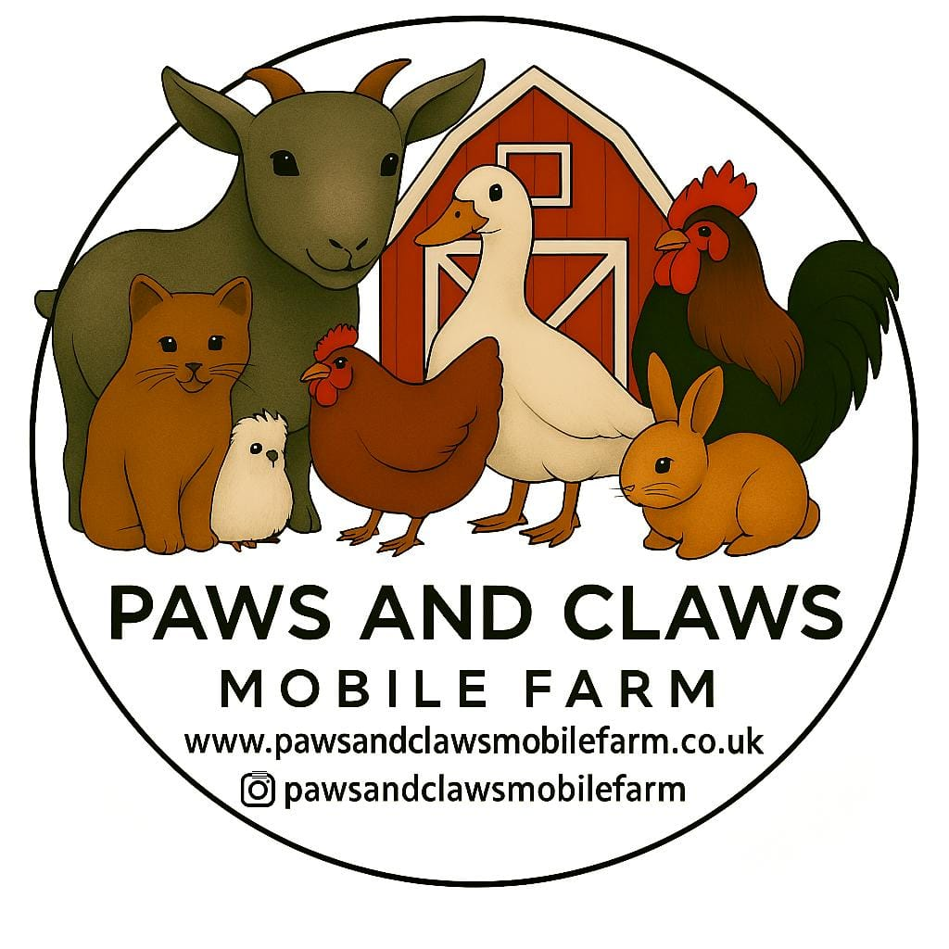
Safeguarding & Child Protection

At Paws and Claws Mobile Farm, the safety and well-being of children and vulnerable people is our highest priority.
We are committed to providing a safe, secure, and supportive environment during all of our mobile farm visits to schools, nurseries and events.

Our Commitment

*Enhanced DBS checked.
Children are never left unsupervised with our team.
A member of school or nursery staff must remain present at all times.
All activities are fully supervised.
Clear behaviour and safety rules are explained at the start of each session.
Professional boundaries are maintained at all times.

Safeguarding Procedures

If a safeguarding concern arises during a visit:
We will listen calmly and take all concerns seriously.
We will never promise confidentiality.
We will report concerns immediately to the school or nursery’s Designated Safeguarding Lead.
In the case of immediate risk, emergency services will be contacted.
Our safeguarding procedures follow guidance from the Department for Education.

Photography

We do not photograph children without prior permission from the school, setting or event organiser. No images are shared publicly without appropriate consent.

Working With Schools & Nurseries

We understand that schools and early years settings have strict safeguarding responsibilities, and we are happy to provide:
DBS confirmation
Full Safeguarding Policy (on request)
Risk Assessment
Public Liability Insurance certificate

