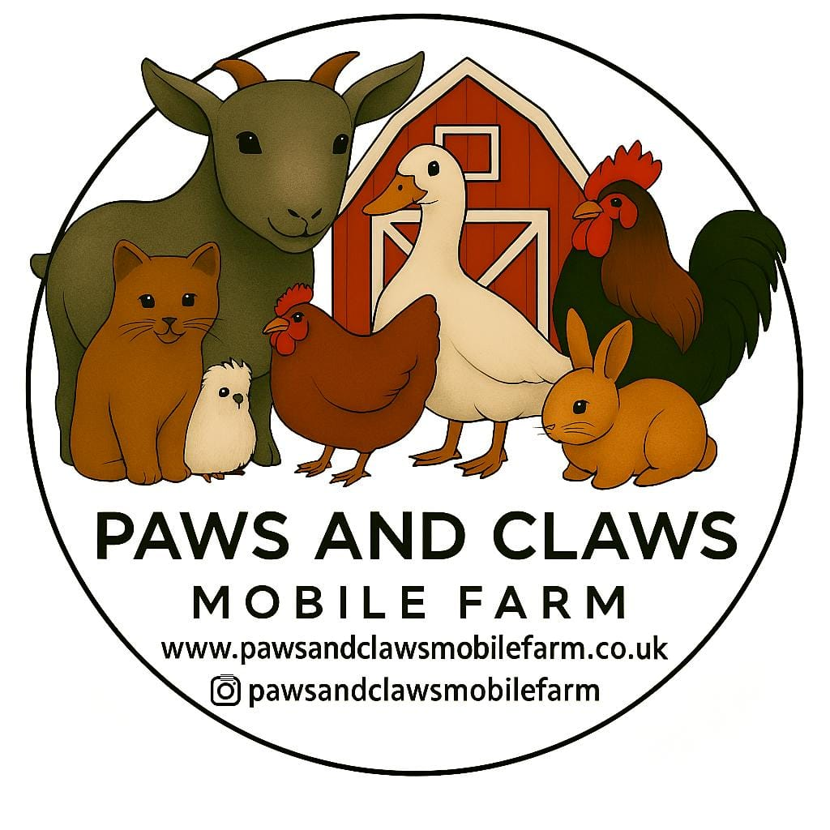

Animal Welfare Policy

Owner: Rebecca Rathore
Policy Created: February 2026
Review Date: February 2026

The welfare of all animals used in educational visits is the highest priority.

Procedures:
• All animals are checked daily for signs of illness, injury, or stress.
• Animals showing signs of illness or distress will not attend visits.
• Animals have appropriate housing, food, water, and environmental enrichment.
• Animals are only used for educational sessions for limited periods and receive regular rest breaks.
• Handling sessions are carefully supervised to prevent stress to animals.
• Animals always have access to a safe space or enclosure where they can retreat if needed.
• Animals are transported and handled in accordance with welfare guidelines.

